**DESKTOP APPLICATION I PROJECT: AIRLINE TICKETING SYSTEM**

**DELIVERABLE 2**

**Marie Andrews & Vishnu Narayanan**

**Module Interaction Flowchart (MA)**

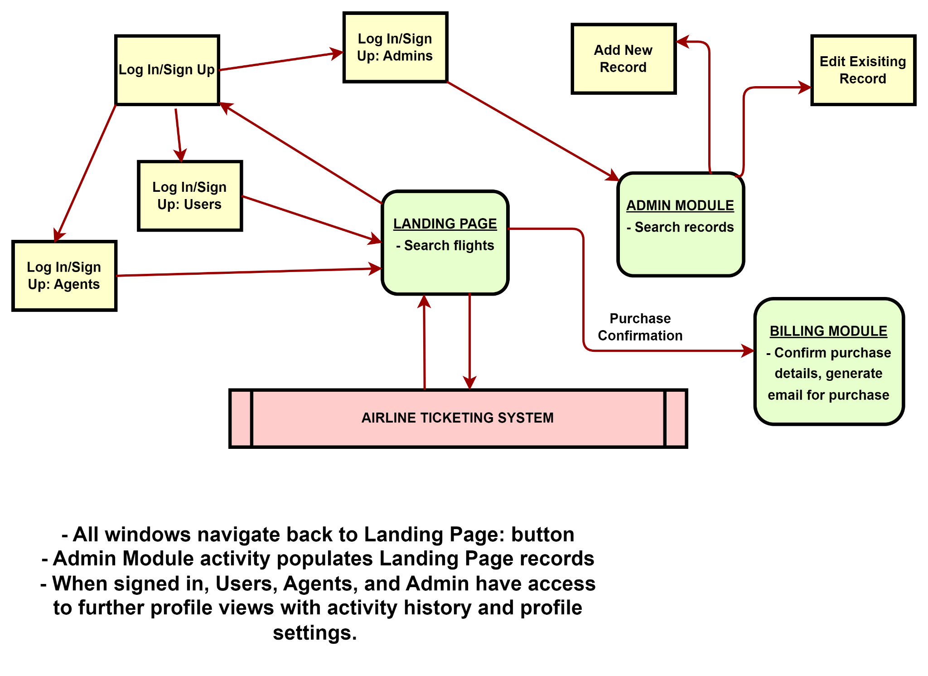

**Work in Progress (MA + VN)**

* Figma design: Landing Page (VN):

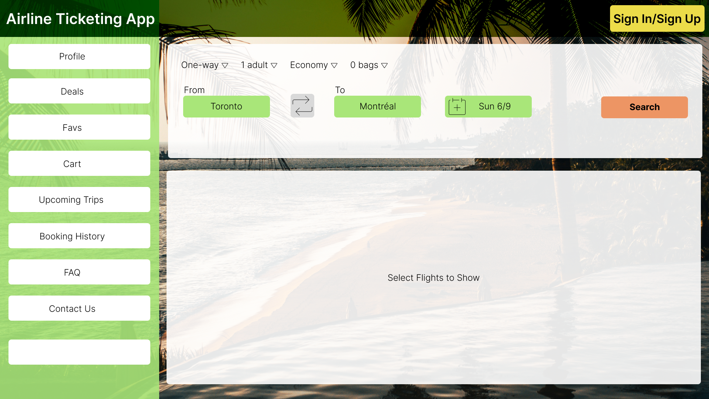

Admin Module (MA):

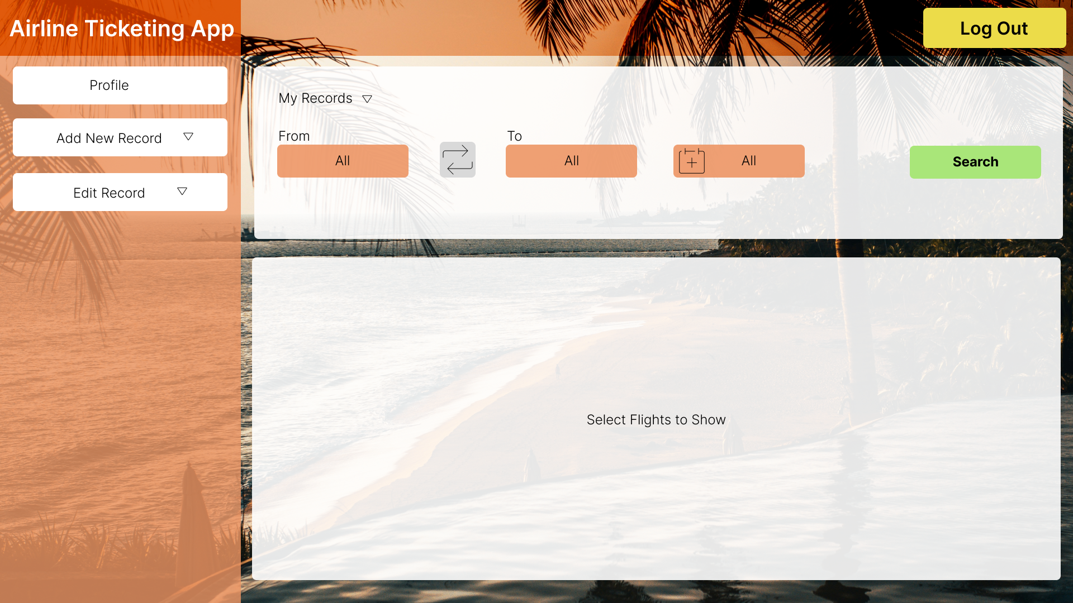

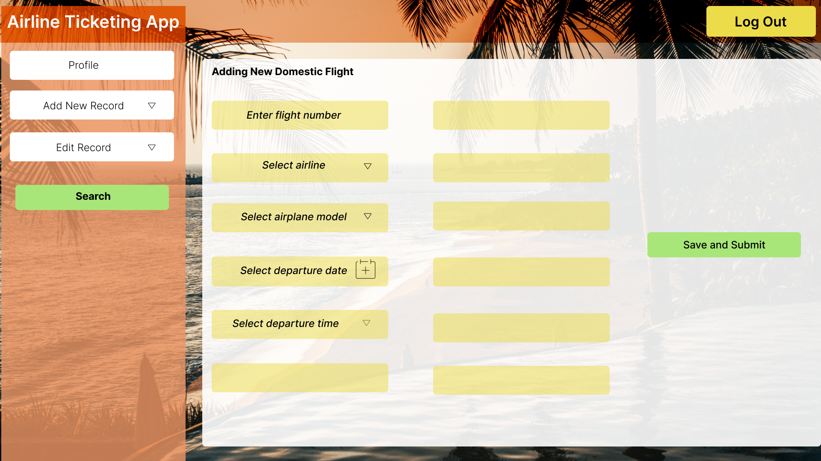

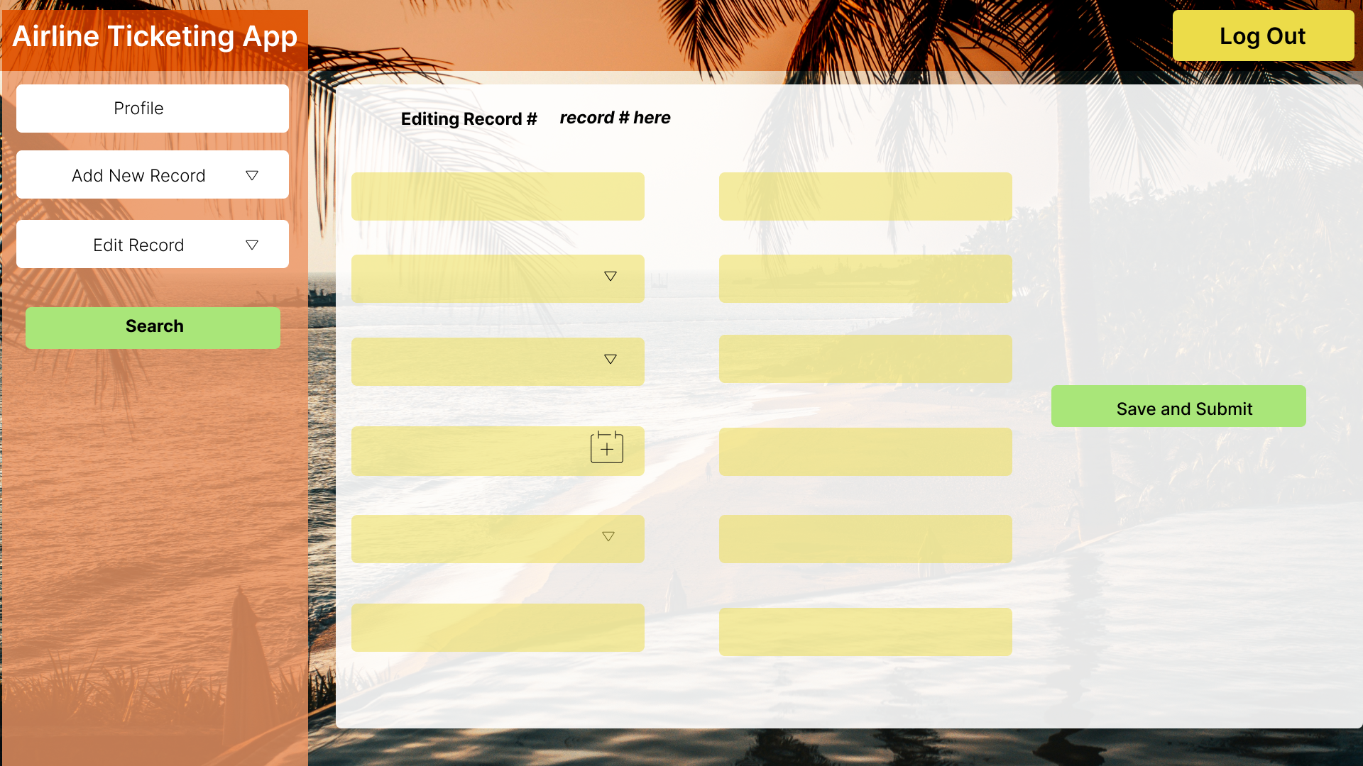

Billing Module (MA):

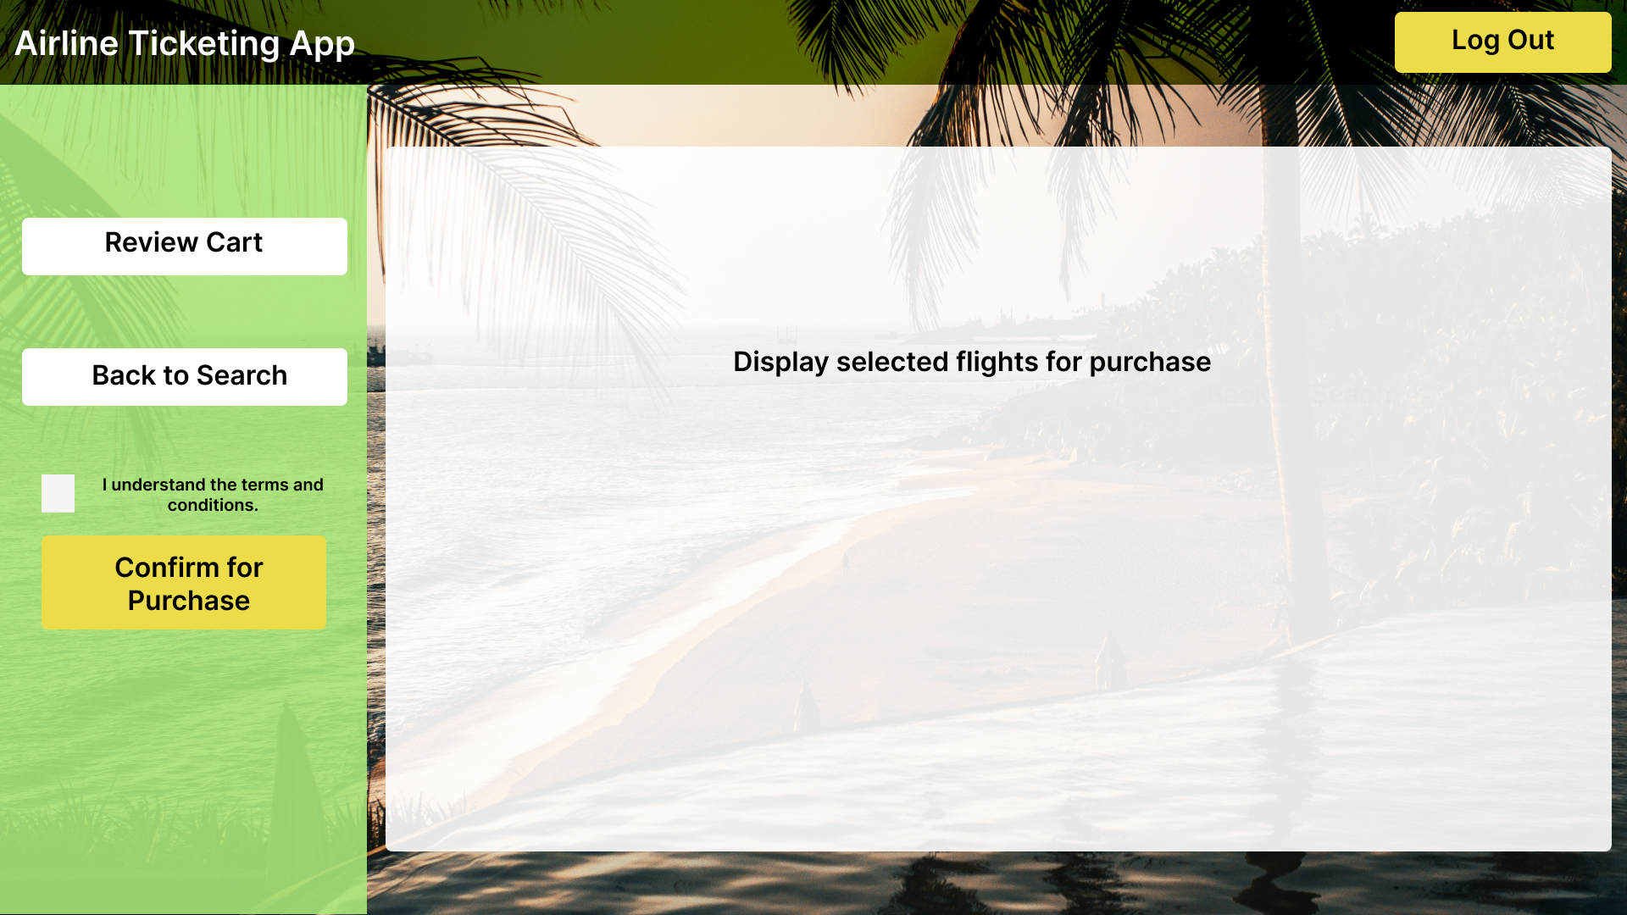

* WPF Landing Page (VN): layout

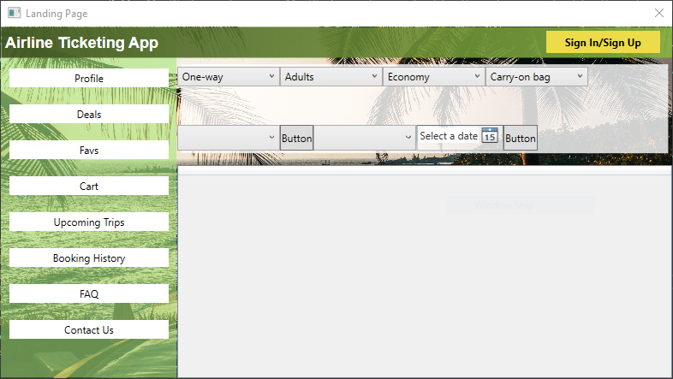

* WPF Sign In/Sign Up (MA + VN): layout, functionality
  + Buttons are functional to link user or agent to registration

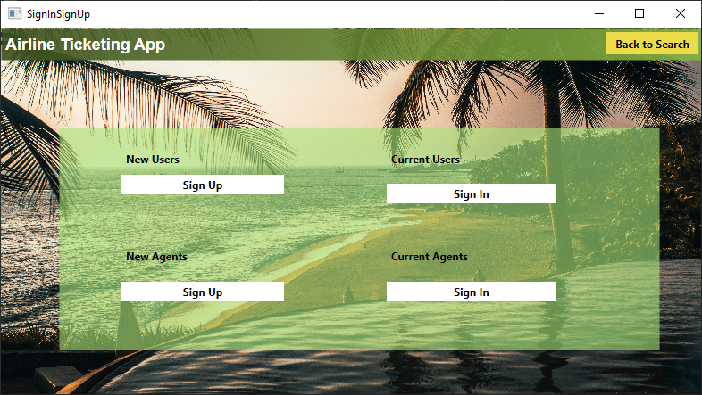

* WPF Agent Sign Up (MA): layout, functionality

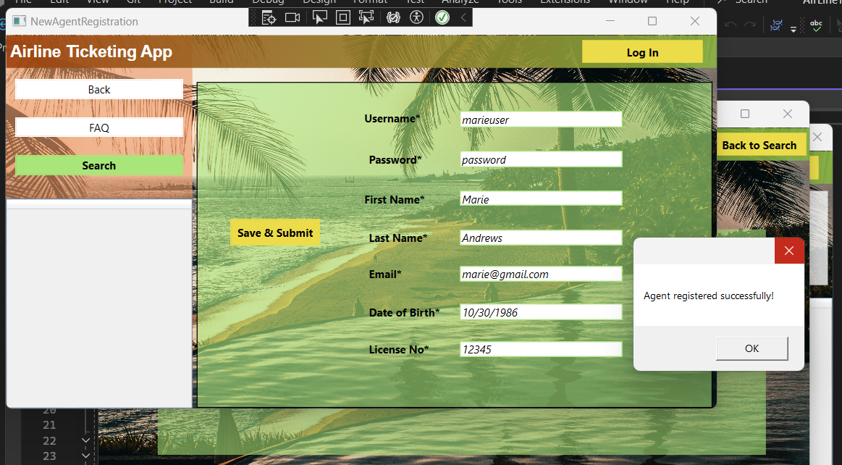

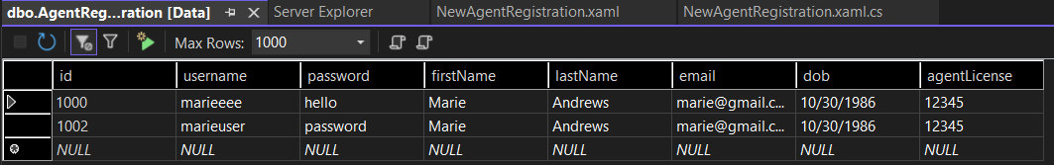

* WPF User Sign Up (VN): layout, functionality

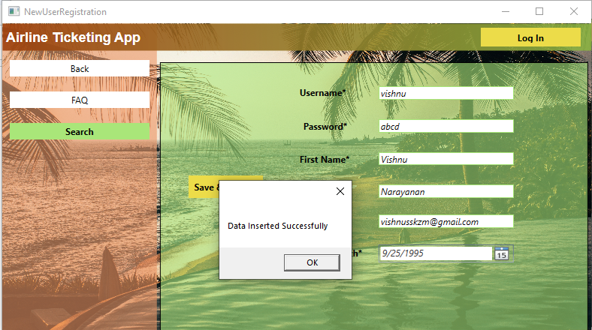

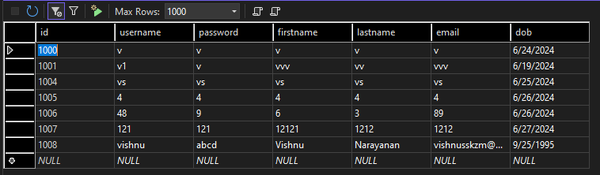

* WPF User Sign In (VN): layout, functionality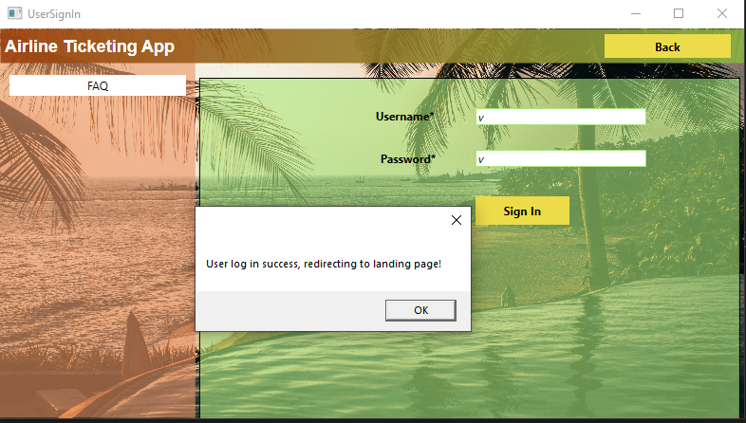

**Tools (VN)**

* .NET 8.0
* Microsoft Server Management Studio 19.3
* Git & Github
* Visual Studio Code

**Schedule (MA + VN)**

Landing Page complete - by 7 July VN

Admin Module complete - by 7 July MA

Billing Module complete - by 14 July MA

NUnit Testing - by 21 July VN + MA